**Manual Chocolatey**

**Acesse o link:**

<https://github.com/chocolatey/choco/wiki/Installation>

**Copie o comando abaixo no cmd execute:**

@powershell -NoProfile -ExecutionPolicy Bypass -Command "iex ((New-Object System.Net.WebClient).DownloadString('https://chocolatey.org/install.ps1'))" && SET "PATH=%PATH%;%ALLUSERSPROFILE%\chocolatey\bin"

**Acesse o link:**

https://chocolatey.org/packages/ConsoleZ

**Execute o comando abaixo no cmd:**

choco install consolez

**Procure por "Man ConsoleZ Module" e execute.**

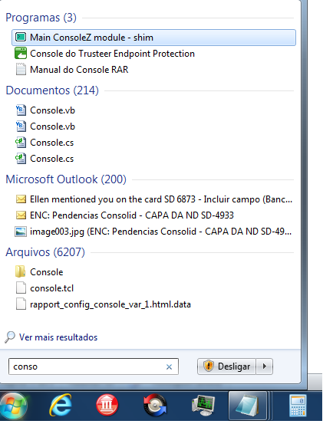

**Após executar ele abrirá um prompt de comando do chocolatey.**

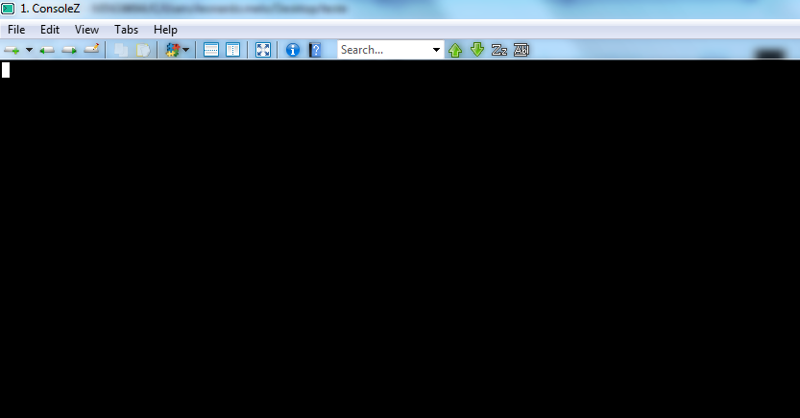

**Clique no menu ->Edit-> Settings e configure conforme a imagem abaixo:**

**Shell:**

C:\Program Files\Git\bin\sh.exe --login -i

**Startup dir:**

%HOMEDRIVE%

